**Assignment: Python Programming for GUI Development**

Name: K. Chethan Gowrav

Register Number:192311394

Department: CSE (Core)

Date of Submission: 26 August 2024

**Problem 1: Real-Time Weather Monitoring System Scenario:**

You are developing a real-time weather monitoring system for a weather forecasting company. The system needs to fetch and display weather data for a specified location.

**Tasks:**

1. Model the data flow for fetching weather information from an external API and displaying it to the user.
2. Implement a Python application that integrates with a weather API (e.g., OpenWeatherMap) to fetch real-time weather data.
3. Display the current weather information, including temperature, weather conditions, humidity, and wind speed.
4. Allow users to input the location (city name or coordinates) and display the corresponding weather data.

**Deliverables:**

* Data flow diagram illustrating the interaction between the application and the API.
* Pseudocode and implementation of the weather monitoring system.
* Documentation of the API integration and the methods used to fetch and display weather data.
* Explanation of any assumptions made and potential improvements

Solution:

Real time Weather Monitoring System

1.Data Flow Diagram

Data Visualization

Weather Analysis

Data Storage

Data Ingestion Data Processing

Data Ingestion

Data Collection

**Implementation:**

import requests

def fetch_weather(api_key, location, unit='metric'):

"""

Fetches weather data from OpenWeatherMap API.

Args:

- api_key (str): Your OpenWeatherMap API key.

- location (str): Location (city name or coordinates) for which weather information is needed.

- unit (str): Temperature unit. Default is metric (Celcius).

Returns:

- dict: Weather data as a dictionary.

"""

base_url = 'https://api.openweathermap.org/data/2.5/weather'

params = {

'q': location,

'units': unit,

'appid': api_key

}

# Sending GET request to OpenWeatherMap API

try:

response = requests.get(base_url, params=params)

response.raise_for_status() # Raise exception for bad responses

weather_data = response.json() # Parsing JSON response

return weather_data

except requests.exceptions.RequestException as e:

print(f"Error fetching data: {e}")

return None

def display_weather(weather_data):

"""

Displays weather information to the user.

Args:

- weather_data (dict): Weather data dictionary from OpenWeatherMap API.

"""

if weather_data is None:

print("Failed to fetch weather data.")

return

# Extracting relevant information from weather_data

city = weather_data['name']

country = weather_data['sys']['country']

temperature = weather_data['main']['temp']

weather_desc = weather_data['weather'][0]['description']

humidity = weather_data['main']['humidity']

wind_speed = weather_data['wind']['speed']

# Displaying the weather information

print(f"Weather in {city}, {country}:")

print(f"Temperature: {temperature}°C")

print(f"Weather Description: {weather_desc}")

print(f"Humidity: {humidity}%")

print(f"Wind Speed: {wind_speed} m/s")

if __name__ == '__main__':

# Replace 'YOUR_API_KEY' with your actual OpenWeatherMap API key

api_key = '0c4fa5058c6fe337e816ef6617ee6d51'

location = input("Enter city name or coordinates (latitude,longitude): ")

weather_data = fetch_weather(api_key, location)

display_weather(weather_data)

OUTPUT :

Enter city name or coordinates (latitude,longitude): chennai

Weather in Chennai, IN:

Temperature: 28.64°C

Weather Description: mist

Humidity: 79%

Wind Speed: 4.12 m/s

**User Input:**

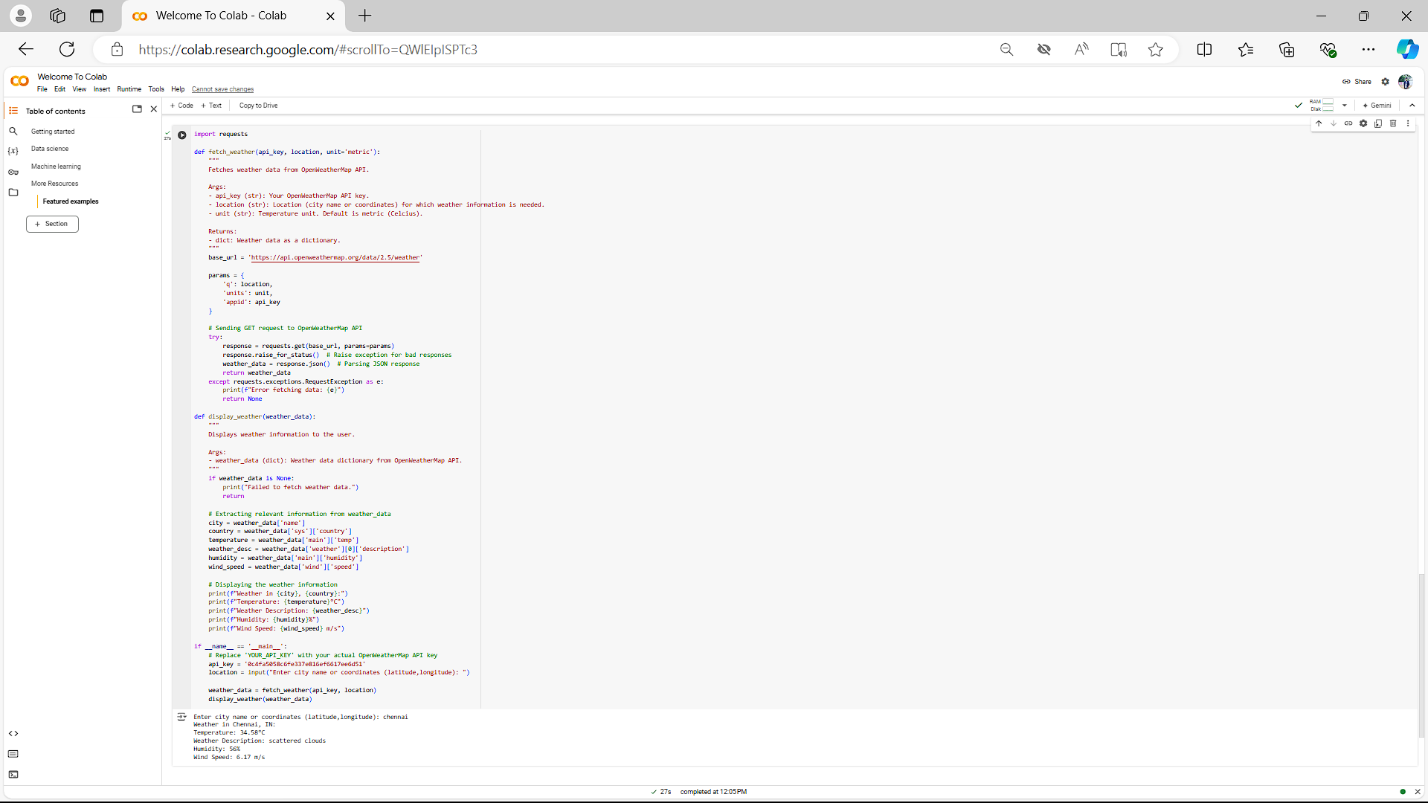

**Documentation:**

API Integration

This Python application integrates with the OpenWeatherMap API to fetch real-time weather data. It uses the requests library to send HTTP requests to the API endpoint (https://api.openweathermap.org/data/2.5/weather) with parameters such as API key (appid), location (q for city name or lat, lon for coordinates), and units (metric for Celsius).

Methods Used

Fetching Weather Data (fetch_weather_data function):

Constructs the API request based on user input (city name or coordinates).

Sends an HTTP GET request to the API and handles the JSON response.

Checks for errors and prints appropriate error messages.

Displaying Weather Data (display_weather_data function):

Extracts relevant weather information such as temperature, weather description, humidity, and wind speed from the JSON response.

Prints the weather information in a readable format.

Assumptions

Input Handling: The application assumes the user inputs either a city name or coordinates in the format latitude,longitude.

API Key: You need to replace 'your_api_key_here' with your actual OpenWeatherMap API key for the application to function properly.

Potential Improvements

Error Handling: Enhance error handling to cover more edge cases (e.g., network errors, invalid input formats).

User Interface: Develop a graphical user interface (GUI) or web interface for better user interaction.

Caching: Implement caching mechanisms to reduce the number of API calls for repetitive requests within a short period.

Additional Weather Parameters: Expand the application to fetch and display more detailed weather parameters provided by the API.

This system provides a basic framework for fetching and displaying weather data from an external API, which can be expanded and improved based on specific requirements and additional features desired for the weather monitoring system.